ICL ScadaWorks Web User Interface Controls Guide

Table of Contents
Web Example 3
There is an online demo of the Web User Interface system which can be viewed anytime at demo.iclinks.com. 3
Web Portal versus the Web User Interface 3
Web User Interface Library of Controls 3
Accessing the ScadaBuilder WUI designer and the WUI Library 4
Working with the Library 5
Editor Key Combinations 6
Parameter Settings 6
Common Control Parameters 6
Working with the WUI Editor 8
The Library Controls 9
The Alarming Controls 9
Alarm Grid 9
Configurable Warning 9
Warning Graphic 10
Alarm Readout 10
Bargraphs and Panels 10
Bargraph Vertical 10
Color Panel with Transparency 11
Panel with Color List 11
Configurable Indicator Light 11
Buttons and Switches 12
Configurable Indicator Button 12
Push Buttons 12
Indicator Buttons 12
Gray Push Buttons 12
Padlock Buttons 13
Checkbox Buttons 13
Rocker Switches 13
Selector Switches 13
Chasers 14
Displays 14
Seven Segment Display 14
Drawing 14
Meters 15
Pipes 16
Pumps and Fans 16
Cooling Fans 17
Pump Jack 17
Compressor and Generator 17
Scales 18
Slider Controls 19
Standard Controls 19
Static Images 20
Tanks 21
Valves 21
Custom library controls 21

Web Example

There is an online demo of the Web User Interface system which can be viewed anytime at demo.iclinks.com.

Web Portal versus the Web User Interface
The Web Portal is a configuration interface built into the ICL controller that is accessed with a web browser. It allows you to configure users and user groups as well as other settings like the controller IP address, etc. There is further information about the Web Portal in the ScadaBuilder help.

The Web User Interface is accessed is through the Web Portal and is a collection of one or more graphical screens that show the current status of a control system such as a pump station, water storage reservoir site, treatment plant process, etc.

To access the WUI pages, a user must first log into the Web Portal.

Web User Interface Library of Controls
The web user interface (WUI) has many pre-built controls that are supplied with the installation of ScadaWorks. The WUI designer is part of the ScadaBuilder program. In order to access your new WUI screens in a web browser, you must first set up an admin user account for the Web Portal.

This is done in ScadaBuilder, in the node settings:
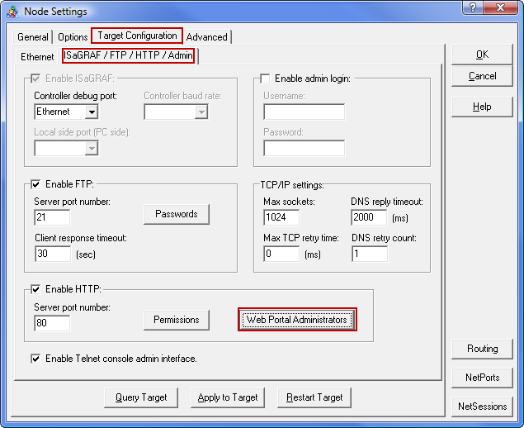

Once the admin login is downloaded to the controller, the Web Portal and Web User Interface can be accessed with a web browser by putting in the IP address of the controller as the web page address.

Accessing the ScadaBuilder WUI designer and the WUI Library
The WUI designer is part of ScadaBuilder program and is accessed in the setup configuration under “HMIs”:
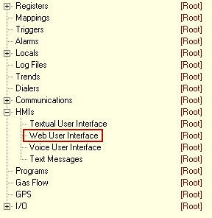

Double click Web User Interface to open the designer.

If the library is not opened automatically, then it can be opened by clicking the library button:
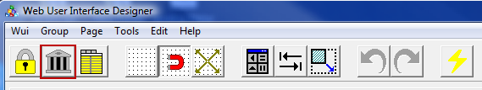

If the designer is opened and there is no WUI already created, then there will be a blank edit area. To create a new WUI, click the “Wui” menu and then the “Add WUI” option:
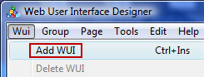

When creating a new WUI, the first dialog will ask you to name the first group. The WUI system has this arrangement:
WUI - Group – Page

The controller can have multiple WUIs, a WUI can have multiple groups, and each group can have multiple pages. This is mainly for organization purposes. For example, the first group may be for the fresh water side of a water district with pages (screens) that reflect those stations, and the second group could be for the waste water side with lift stations, etc. Each page in the designer represents what will be a web page in the final product. Groups are separated in the page listing menu with their respective pages under them.

Once the group name is entered, the edit area will appear. Each page and each control object on the page has configuration options in the “Parameter Panel” which will be to the left of the edit area. If the parameter panel is not already open, then click the parameter panel button:
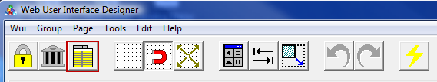

The parameter panel can be closed in order to show more of the edit area if needed.

Working with the Library
Control objects from the library are added to a page by dragging and dropping them from the library to the page. Dropping a new control on top of an existing control is not allowed (It won’t let you do it) when going from the library to the page, but the control can later be moved on top of another object if desired.
A control already in the edit area can be deleted, cut, copied, and pasted by right clicking the control and selecting the appropriate action. You might need to unselect and reselect a control before the right click options show up.

“Aspect Locked” Controls
Some of the control objects in the library are “aspect locked” so that the aspect ratio remains the same no matter what size you make them. The aspect ratio is the horizontal size / vertical size.

Some are locked vertically, some horizontally, and some in both directions. For example, if a control is locked in the vertical direction, then it can be sized horizontally and the vertical size will adjust automatically to maintain the aspect ratio. If it is locked in both directions, then the size must be changed by dragging a corner handle or in some cases by one of the parameter settings.

An example of this is the selector switch which is locked in both directions. The size is changed by grabbing and dragging one of the black “handles”. If you try to make it wider or taller by dragging the side or bottom handle, it will snap back when you let go. In this case the corner handle must be used to change the size.
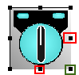

Note that dragging the top or left handle will also cause the control to move. If this happens then use Ctrl/Z to put it back.

Editor Key Combinations
There are several key combinations that are helpful when editing a page. These are listed here:
- Control/Z – This will undo the last edit action.
- Control/Y – This will redo the last edit action.
- Control/Arrow key – This will move the control one pixel at a time in the direction of the arrow key that you’re using.
- Shift/Arrow key – This will change the size of the control one pixel at a time. You can hold the keys down to have a continuous action.
UP – Will subtract from the vertical size.
DOWN – Will add to the vertical size.
LEFT – Will subtract from the horizontal size.
RIGHT – Will add to the horizontal size.

Parameter Settings
The following list details the most common parameter settings. Any controls with unique parameters have those parameters listed along with the control details in “The Library Controls” section.

Common Control Parameters
- Start Reg – This is where the controller register(s) that will control the behavior of the control object is selected/mapped. In some cases multiple registers can be mapped by applying a start register and a block size. The block size is the number of registers to map, including the start register.
Any control that uses a numeric value (anything other than a text string/message register) can have a Boolean, Integer, or Real number register mapped to it. If a Boolean is used where a numeric value is expected, then it will have a value of 0 or 1.
- Clamp Min and Clamp Max – Setting both of these values to zero will disable this feature. If enabled, the value shown on the web page will be clamped to these values, and any value from the mapped register that is over or under the settings will cause the displayed value to stay at the clamp setting until the mapped register falls/rises back into the range equal to or between the clamp settings.
- Scale In Min and Scale in Max– These are the minimum and maximum values that the control will operate on. A value outside of these settings will either be ignored or in the case of a slider control will cause the knob to flash. The slider controls flashing feature is used to indicate an over or under range condition.
- Scale Display Min and Scale Display Max – Setting both of these values to zero will disable this feature. If enabled, the displayed value will be scaled according to the scale min/max and scale display min/max settings.
An example would be for an input that has a raw 4-20mA value (typically 4000-20000), but the preferred displayed value is in engineering units such as the level of water in a tank in feet.
- Integer Width – This setting defines the number of digits that will be displayed for an Integer type number. If the mapped register value has more digits than the setting, the displayed value will only show part of the value.
- Decimal Width – This setting defines the number of digits that will be displayed to the right of the decimal point for a Real type number. If the mapped register value has more digits than the setting, the displayed value will only show part of the value.
- Font Name – This setting for text allows the selection of the font type.
- Font Size – This setting for text allows you to set the font size height in pixels.
- Text Attr - This opens a dialog that allows you to set the text foreground color, text background color, bold, italic, underline, and blinking text.
- Frame Attr – This will create a box around the control. The resulting dialog has settings for foreground color, background color, line width, padding, and radius. The padding is the distance in pixels between the box and the control. The radius refers to the corners of the box which can be curved instead of straight lines.
- Static Thresholds – These settings cause the control to change to specific colors at specific values.
- Register Thresholds – These settings cause the control to change to specific colors at specific values. The values come from values stored in registers giving them user settable values (on and HMI, for example) as well as making the values dynamic. Note that the register mapped to the control as the start register cannot also be mapped as one of the color register.
- Labels – This opens a dialog that allows you to define the way the name/title of a register is presented on the web page. You can choose from the register name, bank name and index, or type in a custom name. You can also click the “Default” button to have the naming done automatically.
- Underline Overide – This is used with text and register fields and can be used either to indicate whether the control is read only (no underline) or read/write (has an underline).
- Text Attr (Text Attribute) - This opens a dialog that allow you to set the text foreground color, text background color, bold, italic, underline, and blinking text.
- Read Only – Makes the control read only or read/write.
- Security Level – This setting works along with the user and user group configurations in the Web Portal to allow a user to make changes to specific controls or have access to specific WUI pages.
- Disable Reg – A control can be disabled (from a user making changes) by mapping this to a Boolean register. The control is disabled when the Boolean is true.
- Invisible Reg – A control can be made invisible on the web page by mapping this to a Boolean register. The control is invisible when the Boolean is true.
- Invalid Data Reg – When this is mapped to a Boolean register and the Boolean is true, a box around the control with a line through it will appear over the control. This can be mapped to a comm fail Boolean to indicate bad data.
- Alignment Group – Any two or more register fields with the same alignment group name will be lined up on the left and right automatically.

Working with the WUI Editor
This section will go over the WUI editor menu options and buttons.
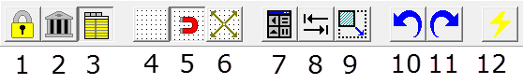
- Lock the design grid – Cleans up the page so that it looks more like what the web page will look like, but no edits can be made.
- Display the library dialog.
- Display the parameter panel.
- Show the design grid.
- Snap controls to the design grid.
- Set the design grid size in pixels.
- Display the control alignment palette.
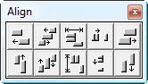
- Display the control alignment dialog.
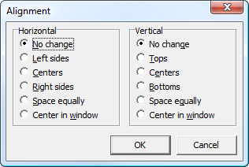
- Display the control resize dialog.
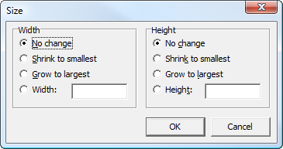
- Undo last edit.
- Redo previous edit.
- Send node setup to target and start. This does the same thing as the lightning bolt in ScadaBuilder and can be used without having to close the WUI editor.

The Library Controls
This section provides information related to each of the provided library controls and how the control operates. This section also shows parameters that are unique to a specific control. Other common parameters are detailed in the “Common Control Parameters” section above.

The Alarming Controls

Alarm Grid
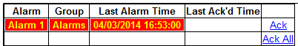
The alarm grid displays a list of current alarms. The Ack And Ack All can be clicked to acknowledge alarms if the current user has the appropriate security level. Parameters that are unique to the alarm grid are listed below.

- Alarm –This setting is used to configure the text attributes for a displayed alarm while it is in alarm.
- Acknowledged - This setting is used to configure the text attributes for a displayed alarm while it is in alarm and has been acknowledged.
- Idle - This setting is used to configure the text attributes for a displayed alarm while it is idle (not in alarm).
- Show Idle Alarms - Setting this to “enabled” will cause idle alarms to be displayed by the alarm grid.
- Show Alarm Grid – This can be used to only show the alarm grid if there are active alarms (acknowledged or not), or if there alarms that are still active but have been acknowledged.
- Group Exclusion - Any group names placed in this list will cause alarms from those groups to not be displayed.
- Group Column Show – This tells the alarm grid whether or not to display the alarm group column.
- Background (Color) – Sets the alarm grid background color.
- Grid Width – Sets the thickness in pixels of the grid lines.
- Grid Pad – Sets the amount of space in pixels between the grid lines and alarm info.
- Grid Color – Sets the line color for the grid lines.

Configurable Warning
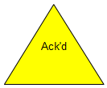
The configurable warning will be in one of three states according to the mapped register value:
0 = The control is not visible
1 = The control will flash and display the alarm text.
2 = The control will be visible but not flashing, and will display the acknowledge text.

Parameters that are unique to the alarm grid are listed below.
- Alarm Text – This parameter is the text that will appear on the control when the alarm is active.
- Acknowledged Text – This parameter is the text that will appear on the control when the alarm is active but acknowledged.

Warning Graphic
There are two warning graphic types that work like the configurable warning graphic, but don’t have any text.
The warning graphics will be in one of three states according to the mapped register value:
0 = The control is not visible.
1 = The control will flash.
2 = The control will be visible but not flashing.

Alarm Readout
These have a color list configuration using the Static Thresholds and Register Thresholds type parameters. See the Common Parameters section for more information about Static and Register Threshold parameters. By default the color list is set to these values:
0 = Grey.
1 = Green.
2 = Red and flashing.

Bargraphs and Panels

Bargraph Vertical
This control is typically used as a level type indicator. The mapped register will control the height of the bar according to value of the mapped register and the scale min/max values.

This control has a color list configuration using the Static Thresholds and Register Thresholds type parameters. See the Common Parameters section for more information about Static and Register Threshold parameters.
By default the color list is set to these values:
Background is black.
Foreground (level color) is cyan.

Color Panel with Transparency
There are round and rectangle versions of this control. They don’t get mapped to a register and are intended as panels to go in front of or behind other controls. The opacity is settable, so they can be transparent. Setting the opacity to 100% will make them non-transparent. The color can be set and they can have a frame.
They will show up as yellow in the WUI designer, but in the set color on the web page.

Panel with Color List
There are round and rectangle versions of this control. They have a color list configuration using the Static Thresholds and Register Thresholds type parameters. See the Common Parameters section for more information about Static and Register Threshold parameters.
By default the color list is set to these values:
0 = Grey.
1 = Green.
2 = Red and flashing.
They will show up as green in the WUI designer, but in the set colors on the web page.

Configurable Indicator Light
The on and off colors for this control can be configured. It is read-only and has no click action.
The colors are set to these values:
0 = Dark green.
1 = Light green.

Buttons and Switches
The buttons and switches are divided into 3 groups (one tab for each in the library).
The groups are Buttons, Checkboxes, and Switches.

Configurable Indicator Button
The on and off colors for this control can be configured. This button has a toggle action. This is a clickable control that can be used to change a mapped register to a true/false (Boolean) or 0 and 1 (Integer or Real).
The default colors are:
On = light green.
Off = dark green.

Push Buttons
These have a 3D look and come in 3 colors. They have a toggle action and latch in the up or down position. This is a clickable control that can be used to change a mapped register to a true/false (Boolean) or 0 and 1 (Integer or Real).

Indicator Buttons
These have a ‘lighted switch’ look and come in 3 colors. They have a toggle action. This is a clickable control that can be used to change a mapped register to a true/false (Boolean) or 0 and 1 (Integer or Real).

Gray Push Buttons
This is a clickable control that can be used to change the value of a mapped register to a true/false (Boolean) or 0 and 1 (Integer). The Off , On and Toggle versions have a counterpart with no text that work the same way. The last 4 are toggle types and two have a lighted indication (green background or red light).

These are clickable controls that can be used to change the value of a mapped register to a true/false (Boolean) or 0 and 1 (Integer or Real).

Padlock Buttons
This has a toggle action and latch in the open or closed position. This is a clickable control that can be used to change a mapped register to a true/false (Boolean) or 0 and 1 (Integer or Real). This control has a settable background color, including transparent.

Checkbox Buttons
This has a toggle action and latch in the checked or not checked position. This is a clickable control that can be used to change a mapped register to a true/false (Boolean) or 0 and 1 (Integer or Real). This control has a settable background color, including transparent.

Rocker Switches
These have a toggle action and latch in the on or off position. This is a clickable control that can be used to change the value of the mapped register to a true/false (Boolean) or 0 and 1 (Integer or Real). The off condition is always gray.
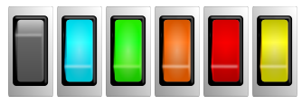

Selector Switches
These come in 2 and 3 position types. This is a clickable control, and the value for each position is settable. They are activated by clicking on the oval “targets” above the switch. The targets are gray if the switch is disabled.
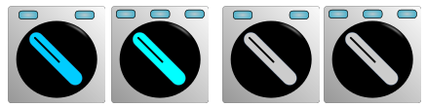

This type also has a color selectable background.
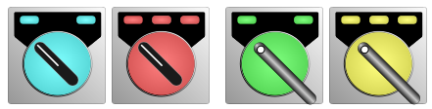

Chasers
These have settable background colors, and the “stripe” is either black or white. They can also have a frame. The stripe will chase from one to the other at a speed that is set by the mapped register value and the range min and max settings.

The direction that the stripe moves (left to right, right to left, top to bottom, bottom to top) is settable.

Displays

Seven Segment Display
This is a clickable control that can be used to change the value of a mapped register to an Integer or Real number value.

Drawing
These are a set of simple drawing objects with lines, corners, arrows, and a circle. The line thickness is set in the parameters. All of these have a line thickness of 10 by default except the circle which has a thickness of 20 pixels.
As an example, drawing objects and a “document link” (see standard controls) were use here to create a folder with the list of documents on the controller:
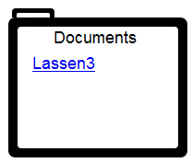

Meters
The meters can be used to visually display a register value along with a colored bar/scale that indicates where there are warnings or alarm conditions. The one shown here has a custom background color setting and uses scale thresholds for the multi-colored scale. See the Common Parameters section for more information about Static and Register Threshold parameters.
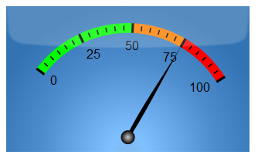

Parameters that are unique to the alarm grid are listed below.
Note that “Marker” refers to the longer marker lines and “Sub Marker” refers to the shorter lines between the markers. Marker “Font” refers to the text used for the numeric values along the scale.

- Scale Width – This sets the thickness of the colored bar in pixels. It starts at the bottom of the markers (the longer vertical lines in the example), and extends outward away from the numeric values.
- Start Angle – You can change the way the scale looks by changing where it starts and ends, thus creating a custom looking meter. The angle is part of a complete circle, and the 0/360 degree point for this circle is where a the 90 degree point is for a normal circle (at the right side half way down).
- End Angle – See the Start Angle above.
- Adjust Radius – This will adjust the size of the circle talked about above for the Start Angle.
- Number Markers – This sets the total number of markers (not including sub markers).
- Marker Width – This sets the width of the markers and sub markers.
- Marker Length – This sets the length of the markers. The sub markers will be ½ the length of the markers.
- Marker Offset – This sets the distance from the numeric values to the start point of the markers.
- Marker Color – This sets the color of markers and sub markers.
- Num Sub Markers – This sets the number of sub markers between any two markers.
- Sub Marker Offset – This sets the distance from the bottom of the markers to the start point of the sub markers.
- Show Marker Values – This will hide or show the numeric values.
- Marker Font – This sets the text font for the numeric values.
- Marker Fontsize – This sets the character size in pixels for the numeric values.
- Marker Font Weight – This is for the bold setting of the numeric values.
- Marker Font Color – This sets the text color for the numeric values.
- Marker Font Offset – This sets the distance from the top of the numeric values to the bottom of the scale.
- Marker Decimal Places – This sets the number of decimals places for when the numeric values are a real number.
- Pointer Color – This sets the color of the needle.
- Shine Opacity – This affects the color of the background by making the colored panel more solid or more see-through. The colored panel is on top of another panel that uses grey scale colors but has the gradient effect. A more solid color will show more of the selected color but less of the gradient effect. The gradient effect gives the appearance of a light source behind the meter.

Pipes
The pipe pieces come in two default sizes (full size and half size) and can be set to specific (and static) color. The size of each piece can be changed also.

Pumps and Fans
The pumps come in 6 styles. 4 of these have settable colors and the other three have a rotating center in the on condition.
Configurable color:

Rotating center:

The ones with settable colors use static and register thresholds. See the Common Parameters section for more information about Static and Register Threshold parameters. The rotating pump spins at a speed set by the mapped register value and min/max scale settings.

The color settable ones have these default colors set:
0 – Grey
1 – Green
2 or greater – Red and Flashing
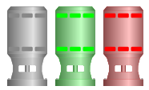

The spinning pumps have these default colors set:
0 – Grey
1 or greater – Green

Cooling Fans
The fans spin at a speed set by the mapped register value and min/max scale settings. They come in two styles, one with a box around the fan and one without.

The cooling fans have these default colors set:
0 – Grey
1 or greater – Green

Pump Jack
The pump jack animates at a speed set by the mapped register value and min/max scale settings. There is no color configuration for this control.

Compressor and Generator
These have a color list configuration using the Static Thresholds and Register Thresholds type parameters. See the Common Parameters section for more information about Static and Register Threshold parameters.
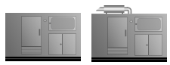

By default the color list is set to these values:
0 – Grey
1 – Green
2 or greater – Red and Flashing
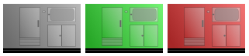

Scales
These are static controls that can be placed by other controls (such as a level bargraph) to associate a numeric value with a visual one. They have a configurable color as well as many other settings.
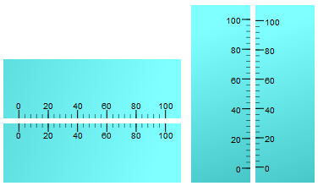

These examples use a custom colored scale and transparency.

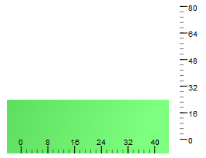

Listed here are the parameters that are specific to the scales:
- Range Left – The scale value at the left side of the horizontal version.
- Range Right – The scale value at the right side of the horizontal version.
- Justification – The horizontal version can have the scale values and marker lines at the top or bottom.
The vertical version can have the scale values and marker lines at the left or right.
- Number Markers – The number of major marker lines.
- Marker Width – The width in pixels of the major marker lines.
- Marker Length – The length in pixels of the major marker lines.
- Marker Offset – The distance in pixels of the major marker lines from the edge of the control.
- Marker Color – The line color of the major marker lines.
- Num Sub Markers – The number of minor marker lines.
- Sub Marker Offset - The distance in pixels of the minor marker lines from the edge of the control.
- Show Marker Values – Shows or hides the numerical values.
- Marker Font – The text font of the numerical values.
- Marker Fontsize – The text font size in pixels for the numerical values.
- Marker Font Weight – Normal or Bold setting of the text font for the numerical values.
- Marker Font Color – The text font color for the numerical values.
- Marker Font Offset – The distance in pixels between the numerical value and the major marker lines.
- Marker Decimal Places – The number of decimal places for the numerical value if it a Real number.

Slider Controls
The slider controls allow you to change the value of the mapped register by dragging the knob of the slider. The slider value is only written to the mapped register when the mouse click is released.
They can also be used to indicate the mapped register while the mapped register value is being written to by some other source such as a program, communication, etc. In this case the control should be set to read only.

The slider control comes in two orientations, horizontal and vertical, as well as single color and multi-color.
The multi-color versions use a color list configuration using the Static Thresholds and Register Thresholds type parameters. See the Common Parameters section for more information about Static and Register Threshold parameters.

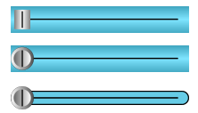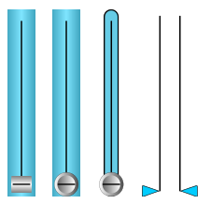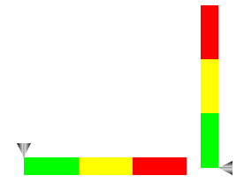

Standard Controls
Most of these are carried over from the older TUI (Textual User Interface) designer to preserve functionality that most of our long time customers are familiar with. Some are new and were added because of the web based enhanced functionality.

- Buffer Field – For putting a message (string) register on the WUI page. Allows for editing also if the user has the appropriate security setting and the field is not disabled.
- Button – This will create a trigger type control on the page. The trigger can be applied to any control that uses a trigger type activation.
- Documents – If any documents are currently present on the controller and the user has the appropriate security setting, then the documents will be listed by name where this control is located.
- Graphical Button – Works the same as the Button control but also allows you to use a picture to represent the button.
- HTTP Link – Will open the default web browser at the specified web link.
- Graphical HTTP Link - Works the same as the HTTP Link but also allows you to use a picture to represent the link.
- Image – Lets you place an image on the WUI page.
- Page Link – Works as a navigation link to one of the other pages in the WUI when clicked.
- Register Field – For putting an Integer, Real, or Boolean register on the WUI page. Allows for editing also if the user has the appropriate security setting and the field is not disabled.
- Text Field – This is a static control. You can put a single line of text on the WUI page.
- Text Memo – Works like the text field but allows you to use multiple lines of text.
- Time and Date – Puts a time or date display field on the WUI page.
- Trend Drop In – Lets you put a trend on the WUI page. This gets linked to one of the existing trends that were configured in ScadaBuilder in the trend configuration section.
- Value List – Lets you specify specific text to be displayed at specific values of the mapped register. The specified text can also be a specific color. The example below shows one possible use and was done with a single value list field.
- Video – Works as an imbedded web browser (without a menu) and lets you specify a web address for a web page that is displaying a streaming video camera. Can be used for other web pages as well, and has settings for displaying a part of the web page at specific x/y coordinates.

Static Images
These are line and cross hatch patterns that can be used to simulate fencing and other types of material at a site. Some of them are densely packed graphics with many lines which can make the web page load slowly if too many are used.
The water texture can be used as a tank level instead of the standard bar graph. This is explained by example in the Tanks section.
Note that when dragging and dropping the water texture into the designer, it is a very large graphic and will completely fill the designer page. You can make it smaller by dragging the size handles just like any other control. They will be at the outer edges of the designer page.

Materials Tab:

Miscellaneous Tab:
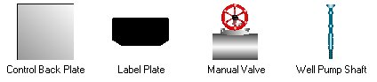

Tanks
There are non-animated versions of all of the tanks that can be used when there is a tank at the site but there is no level indication at the controller. The animated versions use a color list configuration using the Static Thresholds and Register Thresholds type parameters. See the Common Parameters section for more information about Static and Register Threshold parameters.

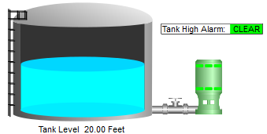

Valves
The valves come in two basic types, the multi position and grey:

For the multi position types, all possible combinations are provided, and each piece for each direction is individually color settable:

The grey types have an ON color and an OFF color which are activated by the value of the mapped register, true/false (Boolean) or 0 and 1 (Integer or Real).

Custom library controls
Building custom library controls is beyond the scope of this document. There is a separate document that shows how to create your own controls available, and training can be provided by ICL. Contact support@iclinks.com if you are interested in learning how to do this.

