

ICL Application Note No. 00034

Alarms and Dialers

This document will walk through setting up a Node that has Alarms and Dialers. It will also go through how to generate your voice files.

Configuring your controller and SCADABuilder for your Modem
This section details how to open a new project in SCADABuilder and configure it for use with your internal modem option. We will assume that you are using an Etherlogic LC for this document, but the options are the same for any model that has the modem option installed. When you begin SCADAWorks and start a new Project you will see the following screen:
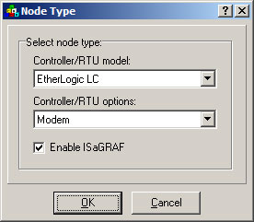

- Select the Etherlogic LC from the Controller/RTU model:” drop down menu.
- Select “Modem” from the “Controller/RTU options:” drop down menu.
- Click OK

This will allow you to use your modem in SCADABuilder. You can now create Network Sessions and events that use this modem.

Creating a Trigger for the Alarm
This information is discussed in Application Note #00024.

Creating the Alarm
- On your main Scadabuilder screen on the right-hand side you should see a section entitled “Alarms”. Double click this section.

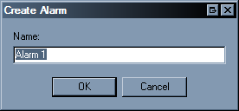
- Please enter a name for your dialer and click OK.
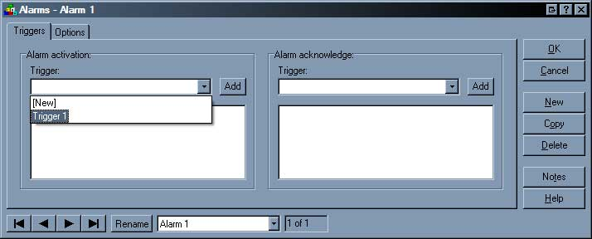
- Once the Alarm window appears, select your trigger.
  - This trigger will act as the activation for the alarm.
  - In order to set the acknowledgement, go ahead and pull down the “Alarm acknowledgement” drop down and select a separate trigger.

- If you click the “Options” tab you will see this screen:
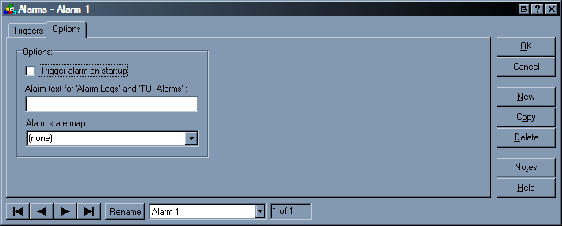
  - Here you can tell your project whether or not to Trigger the alarm at startup;
  - Set the Alarm Text to whatever you might need displayed in your TUI and
  - Map the Alarm state to a buffer for troubleshooting purposes.
- Once you are finished creating your Alarm, click OK.

Creating the Dialer
- On the SCADABuilder main Screen double-click on “Dialers”:
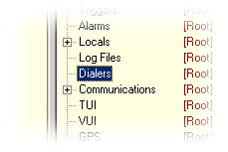
- When the Create Alarm Dialer window appears type in a name for the Dialer:
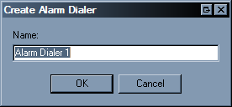
- Click OK.

Configuring your Dialer for Activation
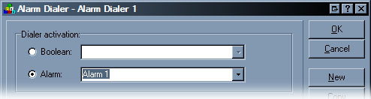
- When the Alarm Dialer Creation window appears select the “Alarm” radio button and use the drop-down menu to select the Alarm you just created.
  - This will activate the Dialer when the Alarm is Triggered (using the trigger you previously configured) (Application Note #00024).
  - You can also select “Boolean” from the two selections to base your alarm off of a Boolean register.

Creating a Call Group
This section will go through creating the Call Group. The Call Group holds the numbers that you will dial with your alarm dialer is triggered:
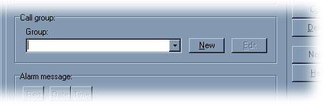
- Click “New” and enter the new name for the call group. Click OK to display the next window:
- Make sure that the modem is correctly selected on the right-hand side of the window.
- Type an introduction message that you want to be heard on every dial. (You can leave this blank if you only need specific messages generated).
- Set you Alarm Messages option on the bottom of the screen.
  - If you need to create an alarm acknowledgement based on DTMF tones you can click the drop down menu and select either a new register from the list or choose a previously made string.
    - In order to acknowledge the alarm when the dialer calls out you will need to press # on your phone after any DTMF combination you set in the Call Group Window.
- Click on the “Dialing” tab
- On this tab you need to type in the phone number that you want to dial.
  - Be sure that you include the area code or any country code you might need.
  - Click Add when you have input your number to add it to the list.
- On the “Alarm Annunciation Retries” options, be sure to set these options to your specific needs.
- Click OK to create the call group.

Creating the Alarm Message
On the final section of the alarm dialer window you need to set up your message options. This window will allow you to customize the message that is heard on your dialer:
- In order to add a register to the message you will first need to select the register from the drop-down menu (or create one if you have not already) and then press the “Reg” button above. This will populate the white area below
  - Date and Time can be inserted without selecting anything.
  - You may type anything you need to into this white area to format the message appropriately.

Generating the Voice Node
Now that you have created your alarms and dialers SCADABuilder is going to need to generate your Voice Node.
- You can start this process by clicking on the “Tools” menu and selecting “Generate Voice…”
- You can also do this by hitting the “Make” button in SCADABuilder. The following window will appear:
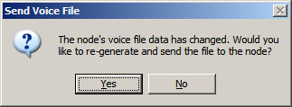

- Click Yes to generate the Voice Files:
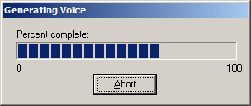

- When the Voice Generation has completed it will transfer this file to the target controller for use when the application is downloaded:
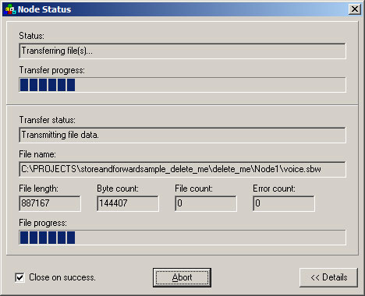

Once the files have transferred you can do a normal download to the controller. You may still need to regenerate the voice node if SCADABuilder prompts you to do so.

Summary
You have successfully configured a dialer/alarm for use with the Voice Node.

Contact Information
Toll Free (800) 888-1893
Local (530) 888-1800
Fax (530) 888-7017
Email support@iclinks.com
Web http://www.iclinks.com
Mail 12840 Earhart Avenue • Auburn, CA USA 95602

